Exit Interview Questionnaire

Name: Vignesh Arvin Govindharaj |  | Emp Id: VIGO0621
Designation: Software Engineer | Grade: | BU: Application Management, Bangalore
Date of Joining: June 17, 2021 | Date of Exit: Dec 31,2021 | NetCracker Experience: 6 months 14 days
Communication email id: arvin.vignesh@gmail.com |  | Communication phone: 9600914154
Address to which exit documents need to be sent: Door No: 3/396, Endapatti (Village), Sugar Mill (Post), Palacode (Tk), Dharmapuri (Dt), Tamil Nadu (state). PIN : 636808

Reflecting Back:

- When you joined NetCracker, what was it that attracted you? What did you like about us?
One of the leading Telecom industry based IT company.
WFH and work time flexibility to improve work life balance
______________________________________________________________________________
- During your time at NetCracker, what did you enjoy most?
Shift time flexibility
Team work
____________________________________________________________________________

- During your time at NetCracker, what did you enjoy least?
Opportunity to development work in my tech stack and skills were not given
____________________________________________________________________________

- If you could change one thing about NetCracker, what would it be?
More development works or at least opportunity for 50% development and 50% support work would be good.
__________________________________________________________________________________________________________________________________________________________
- What circumstances prompted your departure from NetCracker? (Why are you leaving?)
Due to family personal reason, had to move to Chennai, due to this relocation, I wanted to change organization with chennai based work location

__________________________________________________________________________

- What, if anything, could we have done to prevent your departure from NetCracker?
There might not be a way to prevent my exit as I am looking for Chennai location and Netcracker doesn’t have a branch in Chennai because my primary reason for exit is relocation.

____________________________________________________________________________

- In order of priority, what were the top three reasons for your resignation?
Relocation to Chennai
Career enhancement
To involve and learn more in Developer role
____________________________________________________________________________

- What are your future plans? (Where will you be working? Title? Compensation?)
I’ll be working at Wipro as a Software Engineer with 11LPA CTC

_______________________________________________________________________

- How long had you been considering leaving the Company?
3 Weeks before submitting my resignation
____________________________________________________________________________

- Was your workload usually…

Too Much ( ) Just about right (yes) Too little ( )

Reality Check:
How satisfied where you with: ( 0 NA; 1 Not Satisfied; 2 Satisfied; 3 Very Satisfied ) |  |  |  |  | Weight Top 3 *
Quality of your work | 0 | 1 | 2 | 3 | 2
Your compensation & benefits | 0 | 1 | 2 | 3 | 2
Recognition of your work | 0 | 1 | 2 | 3 | 2
Support received from Supervisor / Project Manager | 0 | 1 | 2 | 3 | 2
Your professional growth / development | 0 | 1 | 2 | 3 | 0
Your Career Progression / Promotion | 0 | 1 | 2 | 3 | 0

Comments:
___________________________________________________________________________________

Exit Interview Conducted by:  Signature:  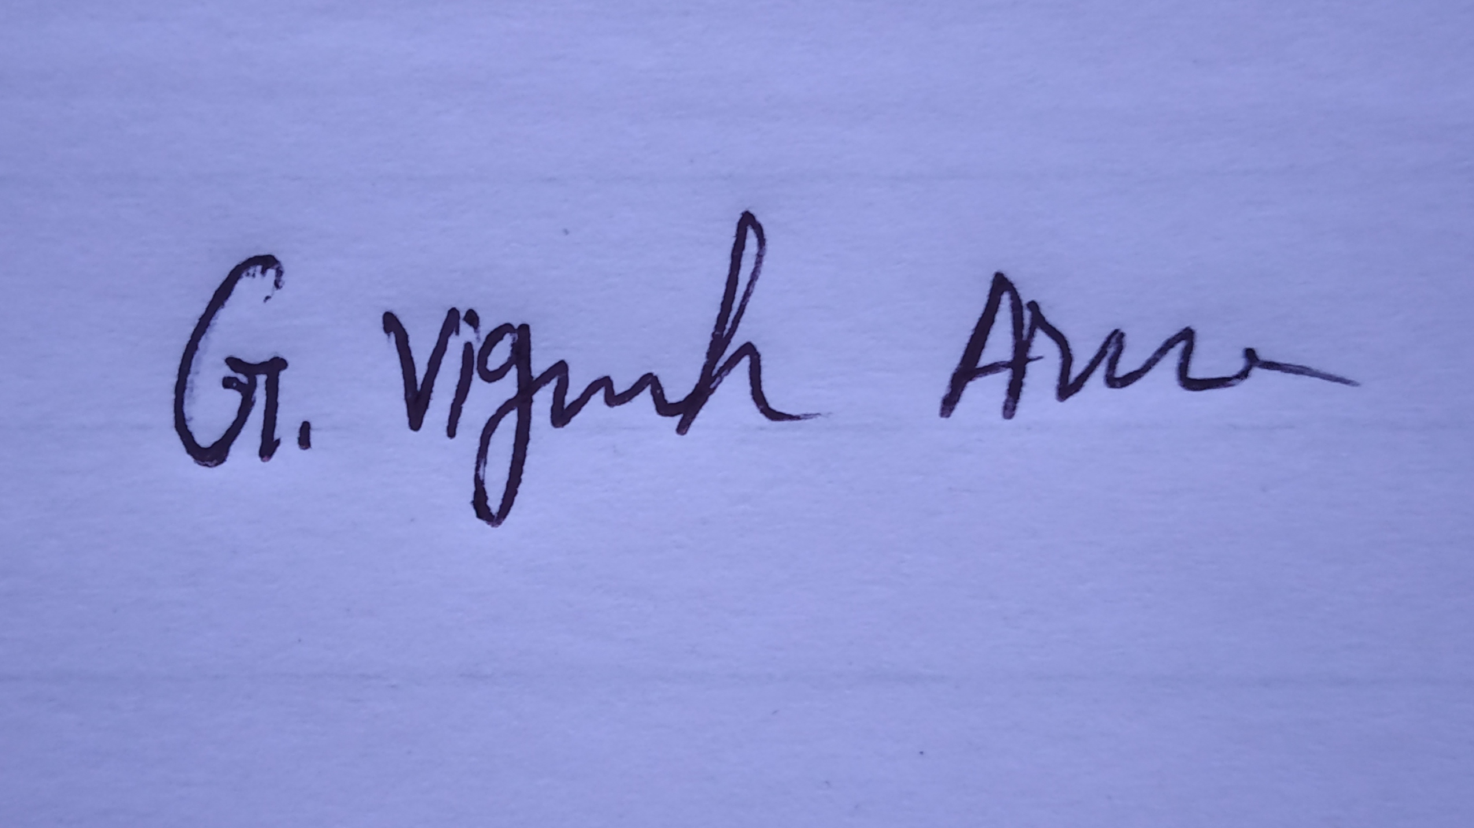 | Exit Interview Conducted on: Dec 12, 2021
Name: G. Vignesh Arvin

